TATA INSTITUTE OF SOCIAL SCIENCES, HYDERABAD

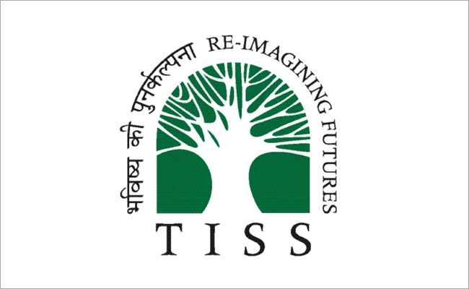

Experiential Learning Report of Group 6

Submitted by:

Ashok Vaditya (RDG) - H2019RDG025
Ishita Sirsikar (RDG) - H2019RDG010
Suvarna Ganta (RDG) – HMO2019RDG002
Venkatesh Katravath (RDG) – HMO2019RDG003
Samarpreet kaur (DS) -H2019DS021
Sunil Topno (DS) – H2019DS031
Sonakshi Bansal (DS) -H2019DS027
Atul Bharti (DS) - H2019DS006

1.Introduction
The following report presents our visiting village Kollapuram in Mandal Gudur and District Mahabubabad as part of the Experiential Learning Program. Before unfolding our journey in this beautiful village, our team would like to thank our faculty Dr. Poulomi Bhattacharya and Dr. Srinivas Surisetti and Palle Srujna volunteers for providing us with a workshop on how to go about in a village and understand their way of life. It is an interesting way to explore a place by venturing into unknown surroundings with unknown context and agenda, to unlearn our assumptions, stereotypes and judgements and get a clearer picture of the reality of villages of Telangana. On reaching the destination, the village took us into awe with its serenity and glaring beauty. On entering the village, we come across its extensive paddy and maize fields. It was a pleasure for us to get invited by the villagers in their house for interaction, carefree laughter and delicious food. It was also a surprise for us to find out the lambada community commonly known as banjaras residing in this village in their traditional Rajasthani attire ghagra peti and white Rajasthani bangles. The following report will try to unfold our journey and unravel our experiences by giving details of our expedition into different headings like education, health and sanitation, employment and migration, festivals etc.
2.Objectives of Experiential learning
The objective is to understand the social, economic, political structure and rural fabric of the village society. The report also tries to emphasize on the quality of education, health, sanitation and employment provided by the government to villagers. It also tries to recognize their daily routine, livelihood and migration patterns and to understand the implications of caste on the distribution of resources.

3.Research Methodology
The group has tried to incorporate various social science research methods to gather qualitative and quantitative aspects of the village, to grasp the reality of surroundings and make a defined analysis of the situations. One of the sampling methods used is cluster sampling to categorize the communities into OC, OBC, SC and ST categories for interviews. It was done to ensure that a clear perspective is derived from all the sections of society. The second method is of quota sampling based on the occupation. It was done to establish a clear picture of society along with its agriculture and non-agricultural occupations. Focussed group discussions were conducted with Vijeetha Youth Association of Kollapuram. The team focused on the open-ended questionnaire for a free discussion with villagers on their significant aspects of life and hence not constraining them to a restricted questionnaire format. The daily meetings and interactions were either in groups of 8 or sub-groups of 4 based on the requirement of the settings. The team had regular discussions in the morning to roll out the plan for the day following by meeting in the evening to gather and compile all the inputs from different sources.
4. Schedule during the experiential learning
The group started their Experiential Learning venture with the train from Secunderabad railway station to Mahabubabad followed by a bus from Mahabubabad to arrive at our final destination Kollapuram during noon. Following is the itinerary of interaction with the villagers.

Day 1
- Meeting with Gram Sarpanch Mr Sudhakar Rao about the history of the village, agriculture and social, economic and political structures of the village.
Day 2
- Interaction with the school headmaster, teachers and students about the school’s achievements and their administration, space, sanitation and financial problems.
- Anganwadi centre worker besides school.
- One on one interaction with the villagers.
- Interaction with the Vijayatha Youth of Kollapuram.

Day 3
- Interaction with the ASHA and Anganwadi worker in Gram Sabha office.
- Attended Gram Sabha meeting to understand the bigger picture of villagers and their problems and its solutions.
- Toddy tappers interaction about their livelihood and its challenges

Day 4
- Interaction with Village Revenue Officer (VRO) to get the inputs regarding the census, land utilisation and agricultural Kharif and Rabi patterns and other pertaining issues like drinking water, employment etc.

Day 5
- Interaction with people of non- agricultural occupations like barber, washerman, potter etc.
- Interaction with ex-sarpanch and members of the SC and ST community.

5. Village Introduction
Kollapuram appears as a small and peaceful village where most of the people have primary education. This village has a government school up to 7th class which was upgraded to English medium two years back. Nearly 80% of the land in the village is meant for agriculture and a major portion of land are acquired by the dominant community. The major crops are paddy, maize, groundnut and chillies. There is no public or private health institution in the village. However, ASHA workers are available in the village. It is 90% open defecation free village and has received best village award at Mandal level. At first, there was no segregation or social division prevalent among the people but with time, it was observed that social division exists in the village and forms the basis of community. Therefore, there was a difference between the initial assumption and final observation.
The male literacy rate is greater than female as observed in the pie charts below. It shows people have a comparative higher preference to send their sons to schools as compared to daughters. According to the 2011 census, the overall literacy rate is very low at about 45% with male literacy rate being 27% and female literacy rate even lower at 18.94%. It brings a dismal image of villagers concerning education in 2011. While interacting with villagers, the team observed that most of the young working population is either migrated to cities of Mahabubabad or Warangal and even many educated individuals have migrated to countries like Singapore and the USA. With this, we expect a better scenario in the upcoming 2021 census.
The total working population is close to 59% hence giving us a picture of unutilized human resource. The percentage of the working population needs to be strengthened by creating employment opportunities through governmental interventions, diversifying the occupation which is still predominated with the hereditary occupation of agriculture.

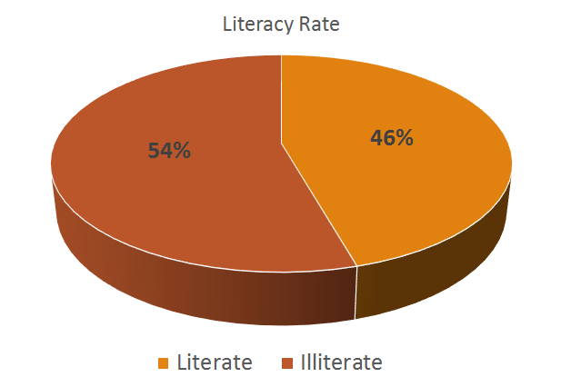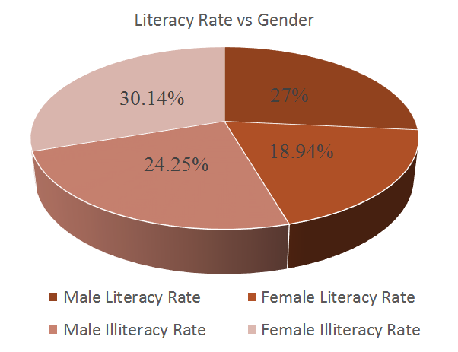

6. Village Mapping
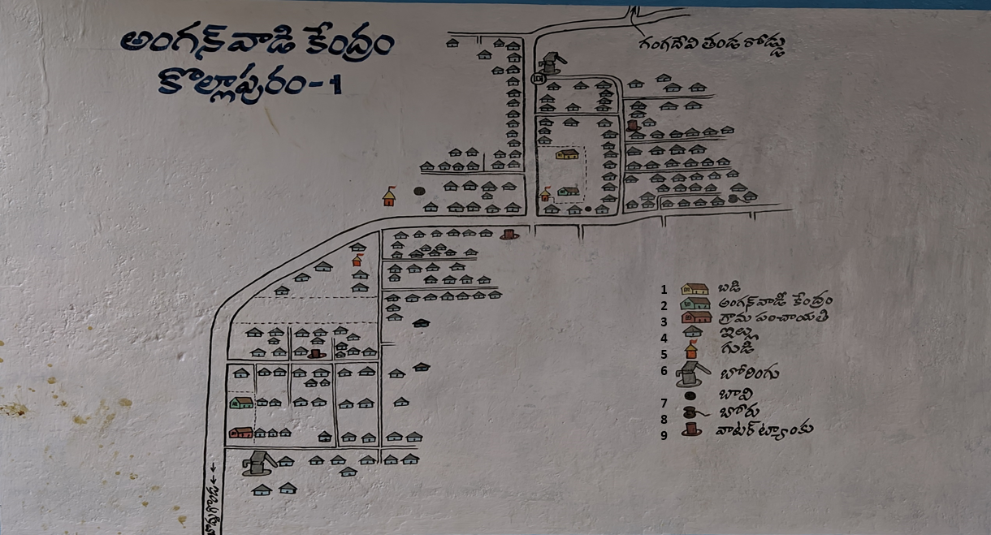
Fig: Village map depicting the allocation of 1. Schools, 2. Aanganwadi Centers, 3. Gram Panchayat, 4. Households, 5. Temple, 6. Handpump, 7. Well, 8. Borewell, 9. Water tank.
It can be interpreted from the village map that there is a school in the middle of the village along with Anganwadi centre and temple. Another Anganwadi centre is in the premises of the gram panchayat. The gram panchayat lies at the entrance of the village. The village has three temples in the village. Although there is no church in the village, there are people following Christianity as their religion and they generally belongs to ST community. The water sources like two hand pumps, two wells, a bore well, and three water tanks are segregated in the village. While going through the village map, the team noted an interesting observation of all the houses aligned at 90-degree angle, which we can familiarize with the pattern of houses built during Indus Valley Civilisation.
7. Village Social Structure Mapping
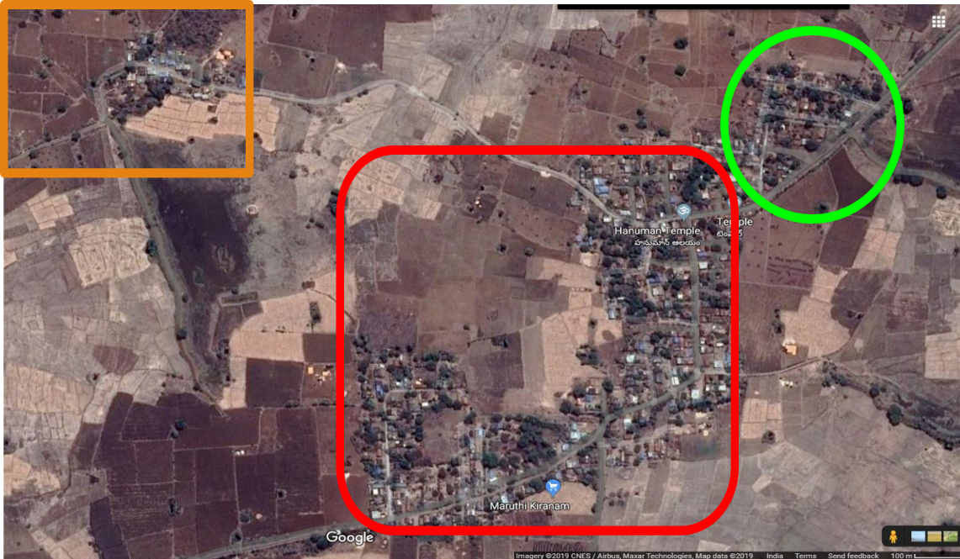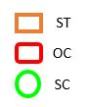
Fig: Village geographical Map obtained from Google Map
source :- http://ccla.telangana.gov.in/Welcome.do;jsessionid=0C249BD409C5B325207664BF5BC72227

As observed from the map, there is no intermixing of the houses. The houses are segregated based on the community. The dominant community is of OC located in the centre of the village. The community on the right is ST and on the left is SC. It carries a significant interpretation that the upper caste community holds a dominant and central picture in the political and social dynamics, whereas the SC and ST community are settled on the margins of the village.
8. Social Composition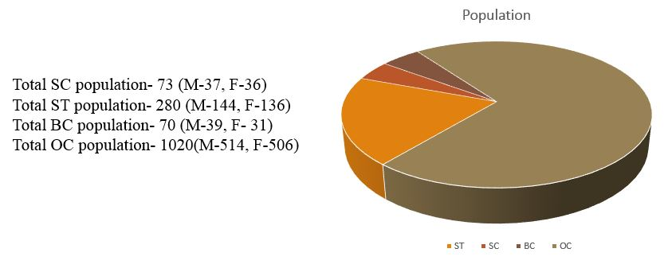
The total population of the village is 1443. The OC population is 1020 (70.69%) out of which male are 514 (50.40%) and female are 506(49.60%), BC population is 70(4.85%) out of which male are 39 (55.71%) and female are 31(44.29%), ST population is 280 (19.40%) out of which male are 144(51.42%) and female are 136(48.58%) and SC is 73(5.06%) out of which male are 37(50.68%) and 36(49.32%) female.
Previously kollapuram was inhabited by the Koya tribe who has been staying in the village for over 60-70 years. These tribes were mainly dependent on forests and its products for their sustenance and were unaware of the intricacies of modern agricultural practices. Over a period of time, the village saw the coming in of many individuals from the Velma community, who were migrating from different parts of Telangana to Kollapuram. These communities had expertise in fields like agriculture and due to the same, they started successfully expanding their land holdings, extracting increasing outputs in terms of money and produce from these lands. As a result of this, the Velma community slowly began to outnumber the traditional tribal community in the village. The village is now dominated by people belonging to the upper caste strata, followed ST, with a marginal segment belonging to SC and OBC communities. The same is observed further in segregation in the field of occupation as well, with the OC population engaged predominantly in agriculture; and the other castes forming the base of other menial jobs due to the lack of land holdings with them.
Such a statistical division is not found between the male and female population of the village, with the difference in absolute numbers between them being marginal. However, in terms of division of labour, women were mainly confined to housework and men dominating the public arena.
The total population is of 734 Male and 709 Female. The sex ratio is 965 females for every 1000 population. The birth rate of male is more than female. The dominance is still of Male population but the situation is better than the sex ratio of India which is 948 females per 1000 males as per 2011 census.

9. Resource Mapping
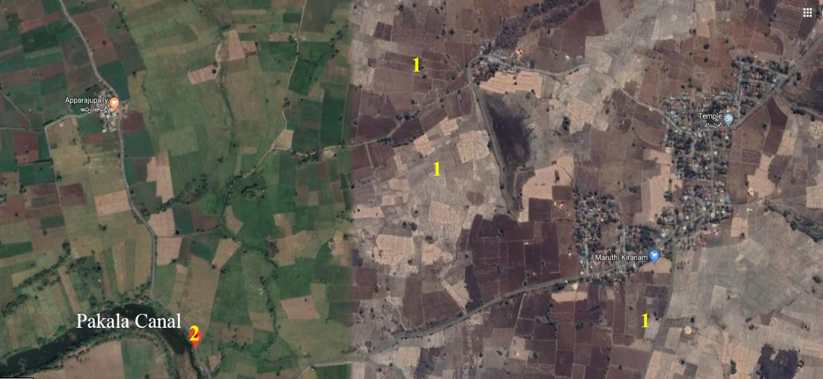
Fig:Landholding And Distribution of Resources (1. Agricultural land, 2. Water Resource)
Source:- http://ccla.telangana.gov.in/Welcome.do;jsessionid=0C249BD409C5B325207664BF5BC72227
The primary occupation of the village is agriculture and the village is surrounded by agricultural land of the villagers (as can be seen in the picture). For water, approximately 2 kms away from the village there is “Pakala Canel” which is the major water resource for irrigation purposes.

10. Landholding and Distribution of Resources
Landholding refers to the ownership of the land. The ownership can be of any kind, such as individual, public or government. Nearly 80% of the land is occupied for agricultural purposes. The major portion of land is acquired by the dominant community known as Velmas. On average, they own 5-6 acres of land. The remaining land is taken up by the other community of SC and ST community with an average of 1-2 acres of land.
The dominant community people are also residing close to other significant resources such as water. Moreover, the agricultural fields of these communities were closer to the water sources as compared to the other communities like ST and SC. We can also figure it out from the resource mapping that the resources are not distributed equally among the groups since the resources such as water used for irrigation is closer proximity of the velmas people.
The landing holding patterns are categorized as marginal, small, small-medium, medium and large.
• Marginal (Less than 1 hectare)
• Small (Between 1 & 2 hectare)
• Small-Medium (Between 2 & 4 hectare)
• Medium (Between 4 & 10 hectare)
• Large (More than 10 hectares)
As mentioned above, the Velmas owns around 5-6 acres of land so they fall under medium landholders. And the other communities such as Scheduled Tribes, Scheduled Caste and Other Backward Classes who holds 1-2 acres of land comes under small landholders.
11. Political Structure
11.1 Administrative Set Up: While interacting with youth in the village, a man was beating the drum to invite villagers for upcoming gram sabha meeting. It is a traditional method followed till day. On reaching the Gram sabha, the team realised that though the quorum shall be one-tenth of the members/voters of the Gram Panchayat meeting as per the rule, it is usually not the followed norm. Gram Sabha composition consists of Sarpanch, MPTC (Mandal Parishad Territorial Constituency), Upsarpanch, Gram panchayat secretary and government official. The government official is the key person to describe all the notifications from the government side and the position is usually held by EC (Engineering Consultant) and in his absence TA (technical assistance) takes up its role. MPTC position is currently reserved for female.
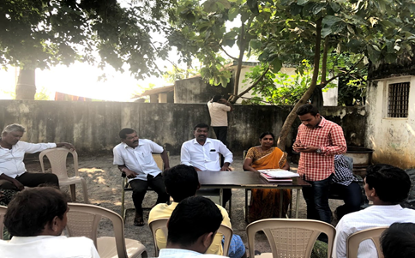
Fig: - Gram Sabha meeting
The Gram Sabha discussion was based on the existing schemes and the changes in the previous scheme like MGNREGA, Haritha Haram and construction of sheds for shepherd etc. A lot of discussions took place between officials and attending members. Generally, meetings revolve around discussions of individual problems, village administrative functioning, knowledge transfer about new schemes and changes occurred in existing schemes.

11.2 Significance of Political Parties in rural society
A negative connotation associated with elections is that, in the name of elections, people are divided due to which the traditional and peaceful environment of a village will get disturbed.
Mobilisation of people to create vote banks is influenced by big political parties at the state or centre level by providing freebies and money. But apart from this, there are many advantages also, as it provides an environment where common people are equipped with the right to question the authority. If the same political parties are in power at the State and panchayat level, there are better chances for the smooth functioning of the process of democracy by providing support and cooperation from both ends. It provides representation and participation of the public hence bringing them in the democratic domain from the grass-root level. It ensures a higher level of transparency by increasing the accessibility of the public to the accountability of political party.

11.3 Local Village Politics
The local village politics is highly divided based on the caste sections of the society. This popular notion was also reaffirmed by interaction with ex-sarpanch belonging to the Yadava community. In the 2014 elections, this constituency was reserved for Backward Caste (BC) community. He told that his unanimous win at the age of 27 was not supported by upper caste community Velmas and hence they create many impediments in his journey as sarpanch. The ex-sarpanch brought multiple developments including renovation of Anganwadi, improving the strength of the school, construction of CC roads, changing existing street bulbs into LED, conversion of Telugu medium schools to English medium etc. Before the 2019 elections, this constituency got converted into OC (Open Category) and hence the then sarpanch found it difficult to fight in terms of money and power with dominant Velmas caste, and eventually stepped down from elections. The 2019 elections were also won unanimously by the present Sarpanch Mr Sudhakar Rao of Velmas community. It highlights that as soon as the constituency is assigned for Open category in elections, the chances of dominant community winning the elections in constituency manifolds multiple times due to their control of power, resources and money. The situation is to maintain the status quo and hence provide higher significance to caste and community status of candidate rather than the experience and performance in the developmental and social work.

12. Education
Education is regarded as one of the key indicators of development. Kollapuram village has a government school which was originally Telugu medium but two years back it has been upgraded to English medium. This has helped the children of the village from the backward classes to gain viable access to good quality education and thereby reducing their costs of studying in private schools. It was observed that most of the children were belonging to farmers, coolie workers, daily wage labourers like construction workers and drivers etc. According to the village Sarpanch, many villagers are sending their children to private schools since it is related to the social status or prestige issues of the people.
One of the major reasons for shifting children from government schools to private schools is the lack of infrastructure. The government school in the village doesn't have proper washrooms for teachers and girls and there is no such provision for boys. The boys rush back to their houses to attend nature’s call and many times they don’t even return to school. The student-teacher ratio seems to be less in the village school which poses as a burden for the teachers to manage the students. While interacting with the headmaster, Mr.Narayana, he mentioned that there are a total of eight subjects but only five teachers are being recruited. So, the existing teachers are assigned to teach other subjects as well, which are not their field of expertise. For example, Hindi should be taught by a Hindi pandit and not a science teacher, this makes the work of teachers more stressful and hence reduces their interest in teaching along with increment in administrative work.
The school has been taking several initiatives to encourage students to take up reading and enhance their vocabulary and knowledge. A unique activity under this initiative is the ‘Talent Test’ which the teachers organise monthly. As a part of it, a speed and accuracy test is conducted wherein students have to write as many words as possible in 100 minutes. The winner of the test is given a cash prize and the money won is often used to buy dictionaries and general knowledge books for the students. Such activities play a huge role in keeping the students motivated and enthused to participate in the class and learn from the same effect.
Government schools have recently started to supply sanitary napkins to girls belonging to class 6th and 7th. Through the mid-day meal scheme, the school is providing nutritious food to the children. Provision for drinking water(10 cans/day) is also made available. It is also noticeable that parents and teachers are contributing in one or other way for the betterment of students. For instance, PTA has brought Projectors for classes which helps to improve the teaching and learning process and, in another case, financial support was given by teachers for a girl suffering from appendicitis.

13. Health Facilities
There are no health facilities available as there is no public or private health institution available in the village. People are required to go to the nearest district Mahabubabad or Warangal District which is 16 km and 13km away respectively from the village. One RMP doctor is available in the nearest village Boddukonda but the doctor is inefficient in treating complicated problems. Only an ASHA worker is available in the village.
13.1 Health Facilities provided by ASHA worker
Accredited Social Health Activist (ASHA) is a female community health activist. The ASHA worker is selected from an area is required to work in the same area or community. This is done to ensure having more information by the worker of that community and the woman can work in a personalized way. The worker acts as an interface between the community and public health institution. The Government has provided 1 ASHA worker for 1000 population in rural areas.
The village has a population of around 1500 and only one ASHA worker working since 2007. Before joining as an ASHA worker, she was working in International Teaching Development Agency (ITDA). She has also received 21 days of training from the Government before joining as an ASHA worker. She is trained to look after T.B. patients, pregnant women, lactating mothers and sanitation along with providing medications for a petty illness.
The ASHA worker in the village is specialized in taking care of women during their pregnancy. She lives in the same village and is almost familiar with every family in the village. Her care starts for respective pregnant women starts after 2 months of her pregnancy. After the completion of 2 months of pregnancy, the worker registers the pregnant woman and takes her to the nearest public hospital for a health checkup. In the Kollapuram village, it is done in the Mahabubabad district. The worker provides all supplements to pregnant women regularly. After the completion of 7 months of the pregnancy, the worker takes the pregnant women to a public hospital for testing and scanning and providing further instructions. During delivery of the child, the ASHA worker takes the women to the nearest public hospital. After the delivery of the child, the worker has the responsibility to take the child and mother for regular health check-up with the regular duration of 1.5 months starting from the second month after the delivery. The ASHA worker takes care of the child and the mother until 5 years of the child.
13.2 Case Study (No health care institution)
Since there is no public or private health care institution available in the village, people are required to go to nearest RMP Doctor to Boddukonda village or nearest Mahabubabad or Warangal district.
During the Gram-Panchayat meeting, while interacting with villagers, the story of an incidence of snakebite came to the knowledge. A person was attacked by a snake and required immediate aid but in the absence of proper health facility, the injured was facilitated by RMP doctor in the nearest village Boddukonda but the doctor was unable to save the injured person. While taking the injured to the nearest district of Mahabubabad, the injured ultimately died. This highlights significant and continuous suffering of the villagers in the absence of standard medical facility. The centre is required immediately to reduce the untimely death of villagers and also it will facilitate in providing employment opportunities.
13.3 Improvement and development in the health sector
The ASHA worker working informed us about the increasing awareness in villagers regarding the health. Initially, people were very apprehensive in coming out of their house and ask for help, especially women, but now people are becoming more open, cooperative and supportive to report every kind of illness. Also, there is 100% institutional delivery in the village along with zero infant mortality rate and maternal mortality rate during the delivery of the child.
14. Sanitation
Sanitation in a broad sense refers to public health conditions relating to clean drinking water and adequate treatment and disposal of human excreta and sewage. Kollapuram is 90% Open Defecation Free (ODF) village. It has received the best village award at Mandal level on the eve of Independence this year among 21 villages of Guduru Mandal.
The villages mapping depicts the existence of three colonies majorly Velma, SC and ST. The people belonging to SC and ST are more prone to poor sanitation in the village. People from this community live in small and poorly constructed Kucha houses. Their houses might collapse at point of time and therefore the residents are not willing to build any toilets which may add to the existing problems. This fact was evident while interacting with a woman from Ippal Thanda. Building toilets in the village is delayed due to delay in the payments for toilet construction and the loopholes in the government where contractors and people who already have toilets at their home involved in malpractices.

15. Anganwadi
These centres are available for pregnant women and children from birth until 5 years of age. Their aim is Mata Shishu Marnalu Thaginchidm i. e. to reduce the death rate of pregnant women under scheme Anubandha Poshaka Ahara Neeluvalu. There are 2 Anganwadi centres in this village. Their function is to measure height, weight, shoulder of pregnant women and young children. They provide nutrition to both women and child with milk, egg and rice, bala-amrutham (cerelac), iron tablets etc. They also provide a suggestion for the blood test, iron medicine, sanitation napkins etc to Kishore Balika of 11-18 years. Their regular work includes the maintenance of daily activity schedule, daily ration schedule and updating the information of pregnant and lactating mother and infant child. These records are checked monthly by government officials The registration of pregnant ladies is first done in the Anganwadi and then further this information is added to ICDS office to maintain the all India information.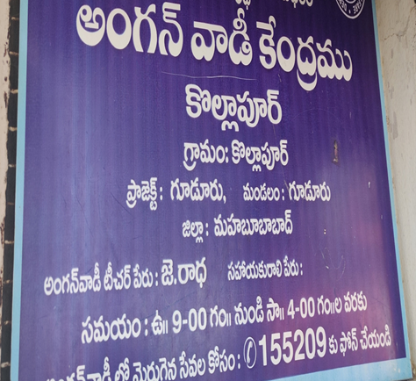 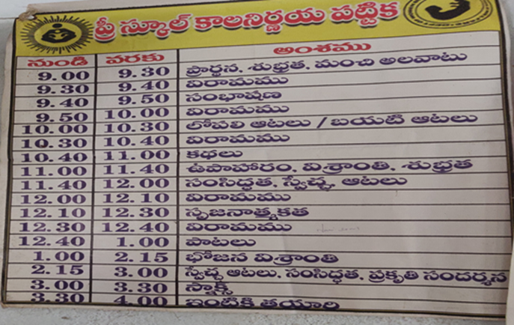
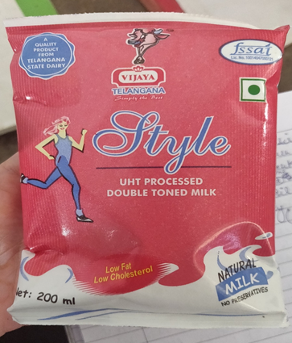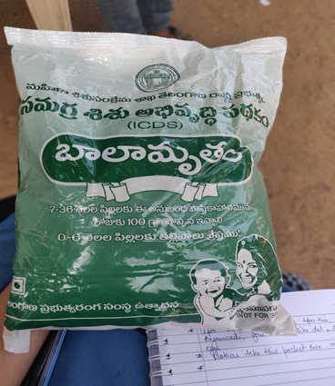
Fig:Milk and Bala -amrutham packets provided by Government of Telangana
The following problems faced by Anganwadi workers regularly. First being the overburden of responsibility of cooking, teaching, teaching and maintaining daily data. As per the government guidelines, there should be 2 aayas for assistance but in reality, one of the Anganwadi workers is single-handedly managing all the chores. There is a death of proper infrastructure. There are no proper washrooms for workers and child. One of the centres even requires a pucca roof. The food is prepared by the aaya or Anganwadi workers from their home. Currently, Anganwadi workers are getting a salary of Rs 10,500 which is not sufficient in current times. There is a problem of irregular ration supply from the government. There are regular cases where the Anganwadi tries to sustain itself without stock for 10-15 days. In these times, even the supervisor also just try to pacify the situation with words instead of taking action of their part and arrange the regular supplies. This problem eventually defeats the whole purpose of providing regular care and nutrition to pregnant women and children.
16. Livelihood and its challenges
Agriculture quite prominently appears as the major occupation as well as a primary occupation in the village. Water being the second major resource of the village, so automatically the agricultural output will be good with the farmers. The government is providing MSP for the production of major crops in the village hence they are going only for the cultivation of paddy, maize, chilly and groundnut etc. DBT farmers are also receiving ₹ 5000 per acre per season through the Rythu Bandhu scheme.
While interacting with farmers, it was evident that the main problem with agriculture was the shortage of labour and because of the same, farmers end up paying a lot of money for agricultural labour services. However, this problem was more prominent among the upper caste framers with huge cultivable land. The small farmers with lesser cultivable land mainly worked on their farms themselves and only occasionally hired labour to do the same. While interacting with farmers, it was evident that the main problem with agriculture was the shortage of labour and because of the same, farmers end up paying a high amount for agricultural labour services.
Regarding the yearly schedule of the farming in the village, it was observed that from July to October, Kharif cropping was taking place followed by Rabi cropping (from November to March) and Zaid cropping (from March to June). It becomes evident that farming is a yearlong commitment hence a farmer works for 365 days in a year and hardly ever takes rest.
Agricultural labour in the village was divided into two broad categories- daily wage labour and annual labour. Daily labourers receive money based on the type of work performed in the field for example -for seeding they get ₹ 250 for 8 hours and for other kinds of work like planting in paddy fields the wages range between ₹400 - 450. Annual labour workers, on the other hand, receive ₹ 80,000 per year.
There are various hereditary occupations followed throughout the year in village which includes the following list

16.1 Toddy topper (Gouda)
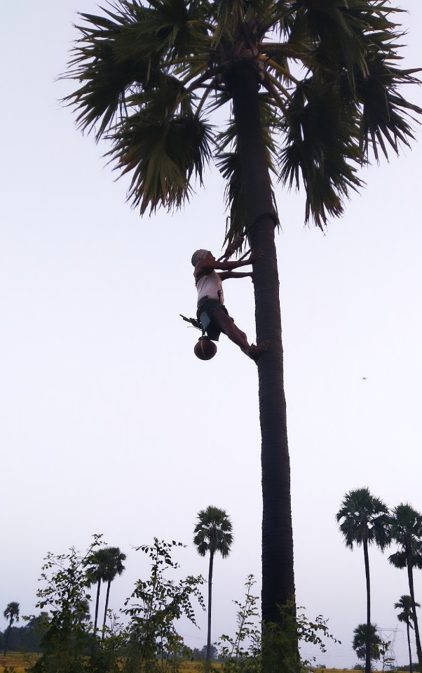
This occupation is practised by the backward community of Goud. Their average income is of Rs 200-300 per day. Their peak season from January to March provides them with an income of Rs 500-1000 per day. There are 200 toddy trees in the village which are divided among 12 toddy toppers of the village through a chit system or a lucky draw process. Some problems faced by them ranges from unseasonal nature of profession to removal of tax to farmers demand of removal of these trees from their respective land. Farmers are cutting down these trees because when the fruit of toddy falls into their fields, a new tree grows out of it and when such a tree is grown with dense root network, it is very difficult for the farmers to cut these trees at a later stage. Another issue raised was the government’s failure to execute project Neera, currently successful project in the states of Kerala and Gujarat. There is also a failure by the successive government by not providing 5 acres of land as promised.
16.2 Shepherd (Golla)
They belong to the Yadava community. They are happy with the government support of providing sheep. However, many of these families already have an excess of sheep and hence selling these new sheep. Instead, they are demanding small pieces of cultivable land to support their livelihood.

16.3 Washer men (Chakali)
There are 12 families of washerman or dhobi in the village. In 2014, the government promised them with the infrastructure of dhobi ghat, shed for ironing and 1 lakh per family. But the promised has not been delivered till now. For getting government benefits, many of them paid an amount of 5000 for registration and insurance but are still waiting to avail the benefits of this scheme. Washer men pointed out that the government is providing regular pensions of 2000/- for old age people from age of 58 plus but the inflation on all products is increasing as well so it is not benefiting them much.

16.4 Potter (Kummari)
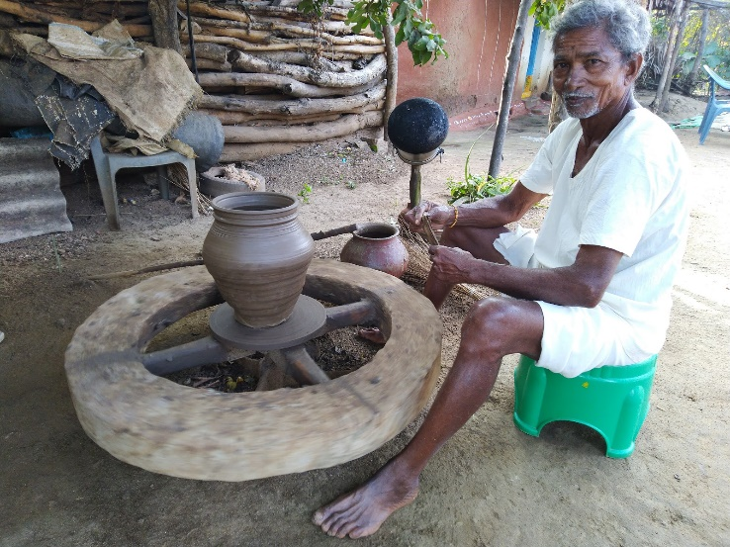
There is a single potter in the village belonging to the Reddy (BCD) community. Soil for pottery comes from field and wood from forests and forest people are also supportive of this community by not putting restriction to provide wood logs. Since the past 30-40 years, he is not getting proper rates for his work as there is no fixed price. The minimum price is Rs 50 and he usually sells around 60 pieces in one month. There has been no increase in purchasing power for decades. A sense of moral hazard was witnessed in our conversations with the potter who had a loan of Rs 30,000. The person can repay but is waiting for the government to wave off his loan. He is also facing the obstacles from the government due to restrictions on cutting forest trees along with government failure to provide a potter's wheel, shed, one lakh for the loan and flourishing use of refrigerators.

16.5 Barber (mangali)
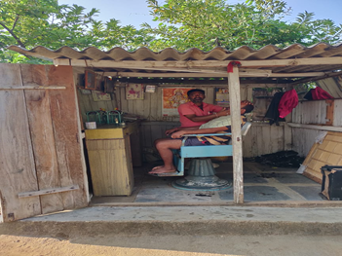
The government had promised to convert his shop from category 1(Rs 4 /unit) into category 2 (Rs 2 /unit) but the government failed to do the same. Since only 2 families are performing this profession in the village, hence no society is formed representing their interests. There is no easy access to loans for buying and setting up advanced infrastructure. The barber in villages lacks training and equipment for stylish hairstyle hence young boys are going to cities to try modern and trendy haircuts.
16.6 Fishermen (Mudirajulu)
They have benefited the most from government schemes like getting bikes and infant fish for the subsidy, but they have a conflict with Banjara and Koya communities.
In conclusion, there are no fixed prices concerning hereditary occupations and there is no intervention from the government in this domain. The cooperative societies are not existing for many occupations along with no fulfilment of pre-election promises. Most of the people are still using their traditional equipment. Mechanization is not pretty evident due to cost minimizing constraints. If there is no support to these hereditary occupations, the next few decades will see the slow and steady death of these non-agricultural livelihoods.

17. Migration and Employment
Migration is often defined as moving from one destination to another. It is an inevitable process,the reasons for the same may be economic, social, political or environmental, as human beings we are constantly searching for opportunities to enhance our capabilities and skill set and are also motivated by better income or earning opportunities.
It can happen due to multiple factors such as employment, occupation, education levels, etc. The main reason for migration is attributed to the push factors i.e. people are not getting any job opportunities in spite of having skill and talent.
Most people are shifting to more populated areas such as Hyderabad & Warangal etc. for better livelihood opportunities. They are also migrating to nearby places such as Godavarikhani city in Karimnagar District. Godavarikhani is also known as the Manchester City, Coal City, City of Black Gold. People are migrating to such places to do daily wage labour, and also to partake in venture jobs. Those who have completed their higher education are also doing jobs in foreign countries like the United States of America (USA), Singapore.
The employment opportunities are abysmally absent. It has resulted in the loss of hope on the government for employment opportunities, especially among the youth. The corruption seems like a significant factor in abstaining even the graduated ones from taking a job. While interacting with the youth of the village, the team came to know about the corruption scam going on in government offices. The job applicant is asked for bribery in the form of a caution deposit of Rs 5,00,000. This has also created an environment where people are not bothered about getting or completing education, instead of looking out for opportunities to make easy money. Majorly the population is employed in agriculture or their hereditary occupations. But the people without land are suffering as they cannot do even agricultural activities and hence have to work as labour on other farmer's land or as daily wage workers in distant districts. They are not aware of government interventions like PM Kaushal Vikas Yojana.

18. Institutions
18.1 Vijayatha Youth Association
The youth represents the most dynamic and energetic section of the population and the future of any economy and society lies in their hands. They often bring out perspectives that might not be overtly evident. In the light of the same, on day two of experiential learning, a focused group discussion with the youth association of Kollapuram popularly known as the ‘Vijayatha Youth Association, Kollapuram’ was conducted. Through the same, the views and opinions of the youth of the village on various existing schemes and other social and cultural practices in the village were gathered.

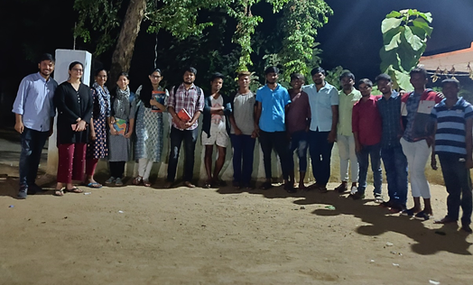
Fig: Interaction with ‘Vijayatha Youth Association’ on 26th Nov ’19 in the school premises

The first topic of discussion was the Rythu Bandhu scheme. According to them, they consider it to benefit only to those who have land and hence could avail benefits from the government on the same. On the other hand, those who are landless and are working as tenant farmers are not benefited under this scheme, therefore the scheme is leading to impact only that section of society who already have land as its resource.
The second notable issue discussed was education and the increasing rate of dropouts seen in villages. Most of the youth who were a part of this discussion was of the age group 20-28 and had completed their basic school level education, however, 3-4 individuals had dropped out of school after class 10th. According to them, two evident reasons were leading to increased dropout rates. Firstly, due to poverty, many individuals prefer to take up easily available jobs for quick money, following the path of many of their classmates following the same. Secondly, for female students, lack of proper sanitation and washrooms was a major reason for the increasing rate of dropouts. A few of these individuals also have graduation degrees, however they are still confined to jobs that are menial and not well paid, including jobs like- driving for taxi services like Uber and Ola as well as food delivery services like Swiggy and Zomato and other jobs in the venture and constructions sectors in Warangal, Mahabubabad or Hyderabad.
The third topic discussed was the construction of toilets under the Swachh Bharat mission and the funds allotted for the scheme. According to the VRO (Village Revenue Officer), to avoid misuse of funds given for construction of toilets, funds are allocated in ‘intervals’ i.e. each stage in the process of building the toilet is evaluated and the requisite amount of money is given to the family after each stage. However, according to the members of the youth association, this is often problematic as there are cases where the construction of toilets is left half done as officials do not turn up for evaluation and the process remains unfinished. Despite this, Swachh Bharat mission has dramatically improved the sanitary conditions of the village and at present Kollapuram is 90% ODF (Open Defecation Free).
The fourth topic of discussion was mission Bhagiratha with focus on its three concerns. First being contrary to what was promised, pipes carrying drinking water were laid only on one side of the road leading to unequal distribution of water. Secondly, often drinking water supplied under this scheme was contaminated and appeared to be yellowish in colour, as a result of this people were using this water for non-drinking purposes. This was problematic as villagers are now spending money to buy mineral water cans at Rs 2 for 20 litres and hence defeating the purpose of the scheme to provide free drinking water to each and every household. Thirdly, the use of traditional sources of water like wells was increasingly declining post the implementation of mission Bhagiratha.
The second aspect of the focussed group discussion deals with the educational and its financial challenges along with social and cultural practices in the villages. The following issues were included. Firstly, there was no library in the school and village. This was due to a lack of funds as well as a lack of space to build the same. The school also did not have adequate infrastructure to accommodate a library. Secondly, one glaring problem faced by the villagers is of alcoholism due to easily accessible belt shops. Although they had stopped manufacturing in one such belt shop near the village, the issue still persists as individual who earlier spent 100 rupees on alcohol would now spend 50 rupees more on travel to buy it from the nearest village. This additional money came out of the family savings and hence was problematic. Thirdly, there was no check on the effective utilization of funds allotted by the government for the celebration of festivals like bathukamma. It is due to a lack of accountability and transparency. The entire utilization of funds was carried out by the sarpanch who is often not very transparent about the same.
The members of this youth organization were all men and women were completely absent from the organization. When their absence was questioned, they explained that due to societal norms girls are not allowed to leave the house after sunset and hence could not attend the meetings conducted by the association.

18.2 Self Help Groups
Women of most households in the village are members of SHGs. There are 12 SHGs in the village with 15 members each. However, these have not been very successful due to the underlying reasons. Firstly, it was found that in certain units, the return from the business is not properly invested and the funds diverted for other personal and domestic purposes like marriage, construction of the house, etc. Secondly, return on investments were not attractive in certain groups due to inefficient management, high cost of production and other.

18.3 Post office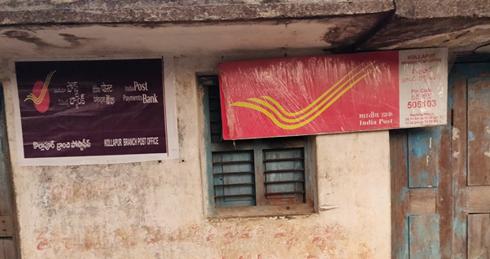Fig: Post-office located in the centre of the village

The Government enacted the MGNREGA in September 2005 and the scheme came into force in all districts in the country with effect from 1st April 2008. Department of Posts has taken the responsibility to disburse the wages through Post Offices by opening savings bank accounts in the names of MGNREGA beneficiaries. This scheme started with Andhra Pradesh Postal Circle in 2005 and is now operational in Kollapuram as well. The Department is also contributing to the efforts in financial inclusion by payment of benefits, Conditional Cash Transfer (CCT) Maternity Benefit Scheme. Such payment is being affected either through money orders or Post Office Saving Bank accounts. In addition to these, the post office is playing an essential role in the implementation of schemes like Sukanya Samridhi scheme under which money is deposited in post offices later collected by the targeted individuals. The village as such did not have any banks however the Mandal had two banks namely Andhra bank and another primary bank.

18.4 Rythu Sangham
Farmer originations were present earlier but don’t exist anymore in the village. An origination known as Rythu Mithra was present in the village earlier, under which farmers contributed money which was deposited in banks, however due to low-interest rates, hardly 1-2% interest rate, the origination eventually dissolved because it was not of much benefit to the farmers who were dependent on this organisation. Caste-based microfinance institutions were prominent throughout the village in various communities whether that be the Velmas or the ippal tanda community.
18.5 Co-operative societies
There was no proper structure of Co-operative societies, while they were present for the dhobi community in the village, the same was not evident in the case of the barber as well as potters’ families.
19. Government Welfare Schemes
The welfare schemes of the Government are actively working in the village. The ten major welfare schemes are- Rythu Bandhu, Mission Bhagiratha, Aasara Pension, Haritha Haran, Arogya Laxmi, KCR kit, Telangana Sheep Distribution Scheme, Kalyan Laxmi/Shaadi Mubarak, MGNREGA, Pradhan Mantri Gram Sadak Yojna, Deen Dayal Upadhyaya Gram Jyoti Yojna.
The most effective and most talked-about scheme among the farmers was the Rythu Bandhu Scheme. A state Government scheme which Direct Benefit Transfer (DBT) a sum of ₹ 5000 in farmers’ account for 2 seasons of the crop (Kharif and Rabi). So, the farmer will get a sum of ₹ 10,000 (in 2 instalments) in one year. The 2nd scheme observed was Mission Bhagiratha. It is a state government scheme with the objective to provide 100 litres of drinking water to rural households and 150 litres to urban households. Water pipelines and taps are present in the village along with a water tank for the storage of clean water. The 3rd was Aasara Pension Scheme and under this, a person would get a sum ₹ 2000 per month from the age of 58. The Haritha Haram Scheme of Telangana Government would provide ₹5 for every sapling planted. The scheme was not very prevalent and people did not have much information regarding this scheme. From the Anganwadi centre, we came to know about Aarogya Laxmi scheme. It is a nutrition scheme by Telangana Government for pregnant women, lactating mother and children up to 5 years of age. A proper food supplement is being provided under this scheme through Anganwadi centres for both mother and child. The KCR kit provides ₹12000 as financial assistance in three instalments to the pregnant women. ₹1000 additional amount if a baby happens to be a girl. This is to promote institutional delivery and reducing infant mortality rate and female foeticide. The KCR Kit consists of 16 items including clothes, baby soaps, oil, powder, mosquito net, napkins etc.
While interacting with the farmers, other schemes like Telangana Sheep Distribution Scheme came to the knowledge. Every shepherd above 18 years of age would get 20 sheep and a “ram” from the government. Also, the Government is providing a sum of ₹ 56,000 for construction of a shed to those having at least 7 cows or buffalos, and also those having more than 22 sheep. Other schemes are Kalyan Laxmi where BPL families will get a sum of ₹ 80,000 for marriage. MGNREGA ensuring 100 days of employment guarantee can be extended to 150 days in the lean season and there were 56 types of jobs available under it in the zila. The village had cemented road constructed under the Pradhan Mantri Gram Sadak Yojana and also 24 hours electricity is available under Deen Dayal Upadhyaya Gram Jyoti Yojana.

19.1 Case study (Problems with Mission Bhagiratha)
While interacting with villagers, there were complaints regarding the contaminated water of Mission Bhagiratha. The colour of the water is not transparent and hence not suitable for drinking. People in the village use this water for other purposes like irrigation etc. Moreover, villagers complained that the pipeline was installed on only one side of the main road of the village so households from the other side have to borrow water. The same issue of contaminated water was questioned by our team to VRO (Village Revenue Officer) in Mandal Office, Guduru. The officer replied that the pipeline goes from the land of the farmers and for their own purpose farmers break the pipe and use the water for their irrigation leading to contamination of water. So, both sides blamed each other for contaminated water.

20. Festivities
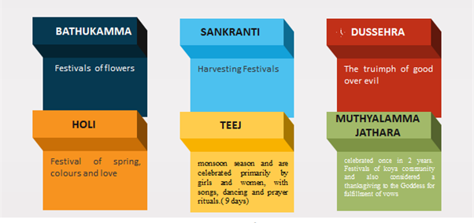

Bathukamma is a colourful and vibrant festival of Telangana celebrated by women with Bathukamma flowers found everywhere in the village. It comes during the latter half of the monsoon before the onset of winter. This festival is celebrated every year in accordance with the nine-day Shathavahana calendar, usually September-October from Bhagrapada Pournami till Durgashtami.
Sankranti also known as Makara Sankranti is celebrated for 3 days with the first day celebrated as ‘Bhogi’. It is a day to discard old clothes and make a new beginning in life.
The second day of the festival is ‘Sankranti’. Chakinalu, appalu and ariselu are the delicacies prepared for the festival of Sankranti.
The third day is ‘Kanuma’. On this day livestock is worshipped by people.
Dussehra is celebrated to emphasize victory of goodness over evil power with victory of Rama over Ravana and victory of Durga over Mahishasura.
Holi is the major festival of Banjara communities. It is the festival of colours and the village people prepare the natural colour by ‘kesula leaf’.
Teej is a nine-day festival celebrated by Lambada tribal women of Eppal where young girls dress in colourful attire. This celebration starts with the sowing of wheat or Bengal gram in bowls on the first day.
Muthyalamma jathara is celebrated by Koya tribes. They constitute 15% of the population in the village. Their major festival is Muthyalamma Jathara which is celebrated once in 2 years.

21. Reflections
As a part of our experiential learning, we came across many instances that forced us to unlearn our existing presumptions of what a village stands for. The following points are an attempt to summarise all our observations and takeaways from our visit to Kollapuram.
As mentioned earlier in the report, there were multiple instances of contaminated water being provided under Mission Bhagiratha which encouraged the construction of a mineral water plant in the village gram sabha. It was built collectively by the villagers and is meant for drinking purpose by providing 20 litres drinking water cans at the rate of Rs 2 per can for residents and 5 rupees for non-residents. There are many leakages in the pipes provided for the supply of drinking water under Mission Bhagiratha resulting in the wastage of water.
Due to evident issues relating to shortage of labour, pre-existing patterns of caste and occupation-based labour were evident. It was observed that the practice of employing individuals belonging to a lower caste in agricultural fields continued to exist and hence caste discrimination is an existing reality but is not openly visible. We didn’t come across any form of organic farming in the village. Many of the individuals engaged in agriculture were not aware of the benefits of organic farming like the low input costs.
When we visited the school in Kollapuram we noticed that long distances of travel are not deterring the students or the teachers from fulfilling their goal of gaining and imparting knowledge. The school's kitchen which was earlier meant for cooking meals for school children were allocated to Anganwadi, therefore the food for children was being prepared and served in the open. Also, the space allocated to the Anganwadi is very small and hence congested for Anganwadi children and the teacher. The teacher taking care of the Anganwadi is often overburdened because the multiple responsibilities of cooking, cleaning, teaching and maintaining the details in registers and she had no helpers contrary to what was promised by the government. The women who were preparing the mid-day meal in school was still using the traditional chullah instead of LPG gas stoves which poses both the health and environment risks.
In terms of the political structure of the village, despite the MPTC being a female, the majority of her work is carried out by her husband. After an interaction with her, we came to know that she is unaware of multiple political and village aspects. This strongly conveys that she was just a nominal head under the hands of the prevailing patriarchal practices prevalent in the village.
The ex-sarpanch, as well as the current sarpanch, were both unanimously elected, which the intention might be to reduce corrupt practices both pre and post-elections. To maintain low opposition, the upsarpanch post was given to the person opposite to sarpanch in elections.
Due to pre-existing cultural and traditional practices, there were no women representatives in the youth organization, however, they did participate in festivities arranged by the organisation in large numbers. The youth, in general, appeared to be very apprehensive and not influential enough to question the government officials as well as the functioning of the village society.
Certain sections of the village are still vulnerable even though the entire village is on the path of development. The people belonging to Ippal Thanda were from the ST community and these people were unaware of the government schemes except for Rythu Bandhu, even though the entire village was enjoying the fruits of this scheme. These people were also not attending gram sabha meetings and were devoid of the benefits of the Anganwadi because of patriarchal and discriminatory practices prevalent in the village. There are very few pucca houses in SC and ST colony and the majority of are living in Kuccha houses. The geographical structure of the village is constituted in such a way that the upper caste is located near the concentrated resources including water accessibility for drinking (water plant in gram sabha) and irrigation (pakala canal).
Due to less accessibility of institutional loans, many people are going for non- institutional loans with higher interest rates which are in some cases leading to suicides because of higher debt.
The twin pit toilets were constructed. It consists of two alternating pits connected to a pour flush toilet. The blackwater (and in some cases greywater) is collected in the pits and allowed to slowly infiltrate into the surrounding soil. Over time, the solids are sufficiently dewatered and can be manually removed with a shovel and reused on-site, much like compost, to improve soil fertility and fertilize crops. Although most pathogens are filtered during soil infiltration or die-off with time and distance, there remains a risk of groundwater pollution, particularly in densely populated areas or in areas with a high groundwater table.
A very praiseworthy aspect of the infrastructure of Kollapuram was that the entire village was well lit with street lights. Also, the roads throughout the village were very well connected through the Pradhan Mantri Gram Sadak Yojana. The scheme includes both CC roads as well as metal and tar road and was built according to the requirements of the village.

22. Group Learning
The visit to Kollapuram as a part of experiential learning has been an extremely enlightening and enriching process for the group as a whole. We have learnt the importance of teamwork and the division of labour. It was also a challenging experience to assign optimize the task by channelling the individual's strengths and collaborating it into a successful learning experience. Each member of our team has played an essential part in putting together this report by providing their unique observations, perspectives and learning forward. It has also helped us to break a textbook perception about villages and hence enabling us to learn and prepare better aptitude for future field visits and developmental work.
The five days away from urban life have been an eye-opening experience for all of us. We were unaware of the working and social structure of the village. Everyone witnessed and analysed the different functions existing in the rural and urban set up in the entire day. Moreover, it was interesting to observe the self-sustaining economy of the village surroundings. Everyone has defined their work based on their hereditary occupation and structure is facilitated by the caste system of India.
Though the government schemes are actively working in the village proper scrutiny is required and there has been a lot to work for proper implementation of various schemes. Above everything, the group was warmly welcomed by villagers. The love and affection were a humbling experience and the hosts took care of the group members as their son and daughters.

